Team14_Project_Neural_Network

Prajwal Gonnade; Supreet Nayak

December 9, 2016

library(boot)

## Warning: package 'boot' was built under R version 3.2.5

library(caret)

## Warning: package 'caret' was built under R version 3.2.5

## Warning: package 'ggplot2' was built under R version 3.2.5

library(class)  
library(ROCR)

## Warning: package 'ROCR' was built under R version 3.2.5

## Warning: package 'gplots' was built under R version 3.2.5

library(MASS)  
library(tree)

## Warning: package 'tree' was built under R version 3.2.5

library(randomForest)

## Warning: package 'randomForest' was built under R version 3.2.5

library(chemometrics)

## Warning: package 'chemometrics' was built under R version 3.2.5

library(reshape2)

## Warning: package 'reshape2' was built under R version 3.2.5

# Neural Network

Occupancy_Train <- read.csv(file.choose(),header=T)  
Occupancy_Test1 <- read.csv(file.choose(),header=T)  
Occupancy_Test2 <- read.csv(file.choose(),header=T)

library(neuralnet)

## Warning: package 'neuralnet' was built under R version 3.2.5

##   
## Attaching package: 'neuralnet'

## The following object is masked from 'package:ROCR':  
##   
## prediction

nn <- neuralnet(Occupancy ~ Temperature + Light + CO2 + HumidityRatio, data=Occupancy_Train,hidden=2,threshold = 0.01, linear.output=FALSE)  
plot(nn, rep = "best")

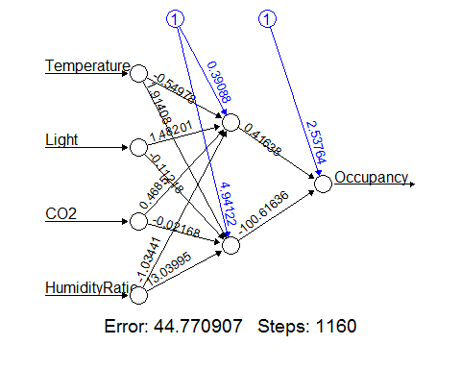

pr.nn1 <- compute(nn,Occupancy_Test1[,c(2,4,5,6)])  
  
results1 <- data.frame(actual = Occupancy_Test1$Occupancy, prediction = pr.nn1$net.result)  
  
table(round(pr.nn1$net.result),Occupancy_Test1$Occupancy)

##   
## 0 1  
## 0 1638 2  
## 1 55 970

mean(round(pr.nn1$net.result) != Occupancy_Test1$Occupancy)

## [1] 0.02138836773

confusionMatrix(Occupancy_Test1$Occupancy, round(pr.nn1$net.result))

## Confusion Matrix and Statistics  
##   
## Reference  
## Prediction 0 1  
## 0 1638 55  
## 1 2 970  
##   
## Accuracy : 0.9786116   
## 95% CI : (0.9723768, 0.9837614)   
## No Information Rate : 0.6153846   
## P-Value [Acc > NIR] : < 0.00000000000000022204  
##   
## Kappa : 0.9543747   
## Mcnemar's Test P-Value : 0.000000000005675414   
##   
## Sensitivity : 0.9987805   
## Specificity : 0.9463415   
## Pos Pred Value : 0.9675133   
## Neg Pred Value : 0.9979424   
## Prevalence : 0.6153846   
## Detection Rate : 0.6146341   
## Detection Prevalence : 0.6352720   
## Balanced Accuracy : 0.9725610   
##   
## 'Positive' Class : 0   
##

pr.nn2 <- compute(nn,Occupancy_Test2[,c(2,4,5,6)])  
  
results2 <- data.frame(actual = Occupancy_Test2$Occupancy, prediction = pr.nn2$net.result)  
  
table(round(pr.nn2$net.result),Occupancy_Test2$Occupancy)

##   
## 0 1  
## 0 7624 9  
## 1 79 2040

mean(round(pr.nn2$net.result) != Occupancy_Test2$Occupancy)

## [1] 0.009023789992

confusionMatrix(Occupancy_Test2$Occupancy, round(pr.nn2$net.result))

## Confusion Matrix and Statistics  
##   
## Reference  
## Prediction 0 1  
## 0 7624 79  
## 1 9 2040  
##   
## Accuracy : 0.9909762   
## 95% CI : (0.9888941, 0.9927565)   
## No Information Rate : 0.7827112   
## P-Value [Acc > NIR] : < 0.00000000000000022204  
##   
## Kappa : 0.9731507   
## Mcnemar's Test P-Value : 0.000000000000190321   
##   
## Sensitivity : 0.9988209   
## Specificity : 0.9627183   
## Pos Pred Value : 0.9897443   
## Neg Pred Value : 0.9956076   
## Prevalence : 0.7827112   
## Detection Rate : 0.7817884   
## Detection Prevalence : 0.7898893   
## Balanced Accuracy : 0.9807696   
##   
## 'Positive' Class : 0   
##